**ORM Web Services**

**Midterm Project: Article Management**

**Group: 3**

Member of Group 3: **NANH Bunsin**, **Ngorn Lyhour** & **CHHAY Laing**

**Note:** all ER Diagram files we already store them into git repo into folder public like ER Diagram and docs.

Content

* Responsible By NANH Bunsin and some assist from Lyhor

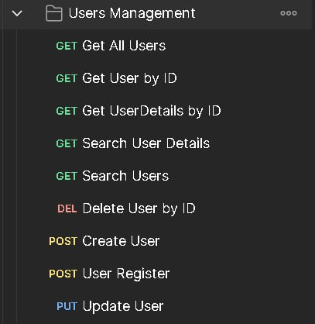

To create Api below:

* Get All Users
* Get User by ID
* Get UserDetails by ID
* Search User Details
* Search Users
* Delete User by ID
* Post Create User
* Post User Register
* Update User
* Responsible By Ngorn Lyhour

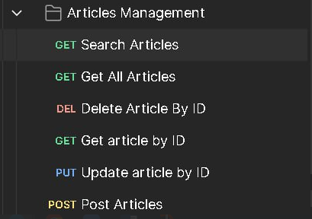

To create Api below:

* Get Search Articles
* Get All Articles
* Delete Article By ID
* Get Article by ID
* Put Update article by ID
* Post Article
* Responsible By CHHAY Laing and some assist from Bunsin

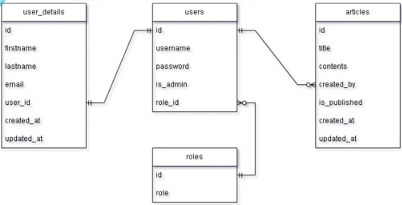

To create 4 Tables and ER diagram:

* Users
* User_details
* Articles
* Roles

ER diagram user Admin:

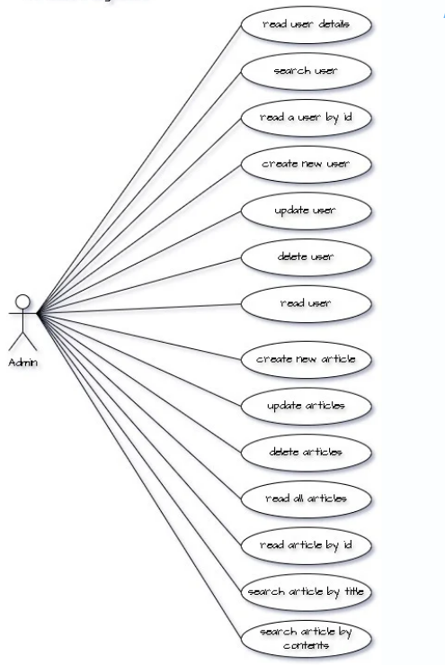

Note: all project ideas we are collaboration together and presentation slide as well.